**Instructions:**Replace **[bracketed red text]** with the requested information or screen capture.  
Replace **bracketed red text with black text**.  
**PLEASE do not include full page, full window screen shot images**, or full screen shots that have been reduced in size.   
Use a snippet tool to capture parts of the screen and insert those images into the template.  
**Do not remove tags from this template. An example of a tag is [C01]. All fields are required.***Please do not alter template formatting or delete parts of this template.*

Part A - Student Information:   
 **1. Student Name: Brian Salinas**

**2. Class Designation: IN-CLASS**

**3. Did you complete the activity before starting this assignment? Yes**

**4. Did you work with any other students on this assignment? No**Part B –CMS Webhost Information:

**1. Which web host did you use for this assignment, Shared web-host SiteGround (another shared web host) or Pantheon or Cloud web development environment?**

**SiteGround**

Part D – Drupal 8 Site Configuration

Drupal 8 Screen Captures:

1. SCREEN CAPTURE – Backend Account Settings, REGISTRATION AND CANCELLATION  
   Admin toolbar > Configuration > Account settings, Registration and Cancelation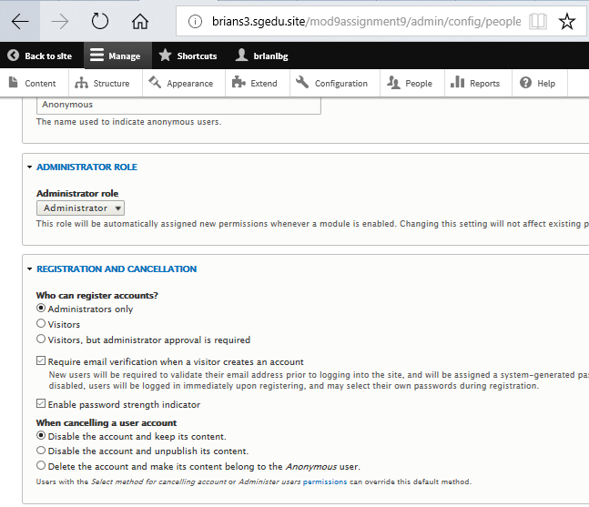 [D01]
2. SCREEN CAPTURE – Backend Appearance  
   Admin toolbar > Appearance showing the Default client facing-theme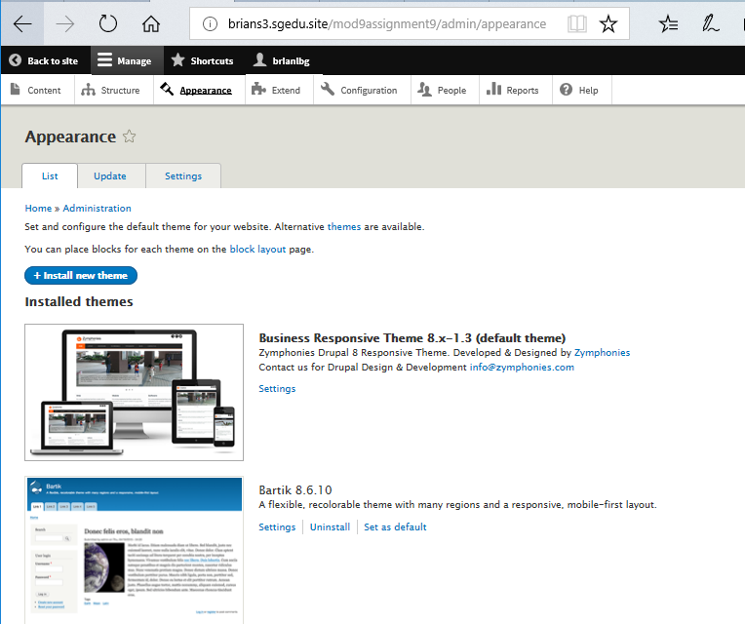 [D02]

Part E – Drupal 8 – basic pages

Drupal 8 Screen Captures:

1. SCREEN CAPTURE – Backend List of Basic Page nodes you created  
   Admin toolbar > Content, Filter content by Basic page before taking screen capture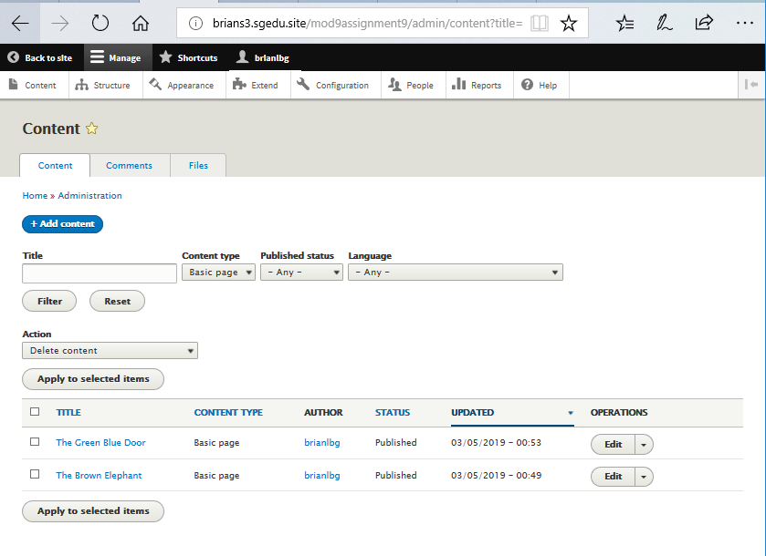 [E01]
2. SCREEN CAPTURE – Frontend screen capture of the Brown Elephant page.  
   Note: Frontend means a web browser where you are not logged into the Drupal site.  
   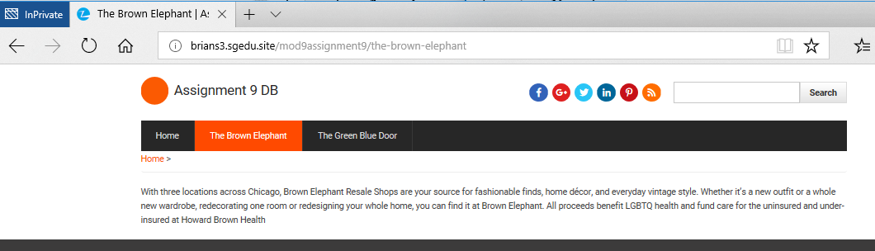 [E02]
3. SCREEN CAPTURE – Frontend screen capture of the Green Blue Door page.  
   Note: Frontend means a web browser where you are not logged into the Drupal site.  
   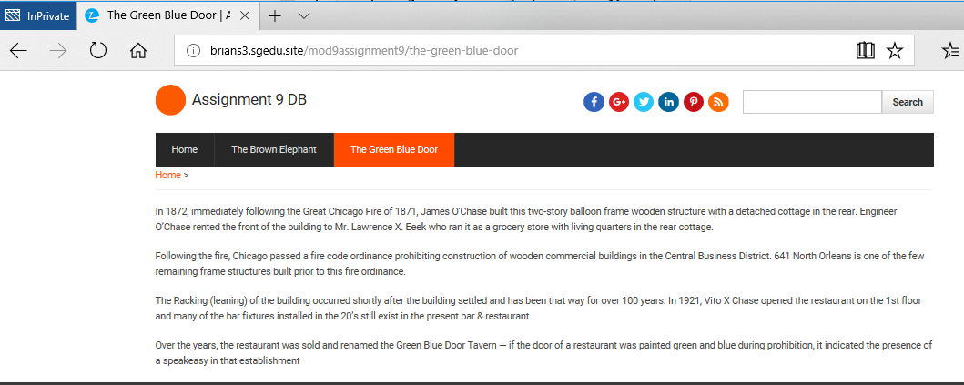 [E03]
4. Go back to the instructions and continue with Part F.

Part F – Drupal 8 Site Articles:

Drupal 8 Web Host Screen Captures:

1. SCREEN CAPTURE – Backend List of Article nodes you created  
   Admin toolbar > Content, Filter content by Article before taking screen capture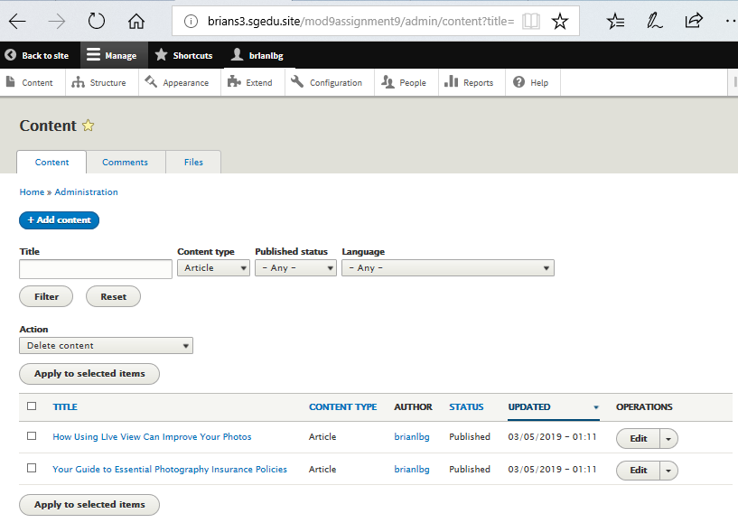 [F01]
2. SCREEN CAPTURE – Backend Article nodes Title and Tags  
   Edit an Article you created and take a screen capture the top title, tags 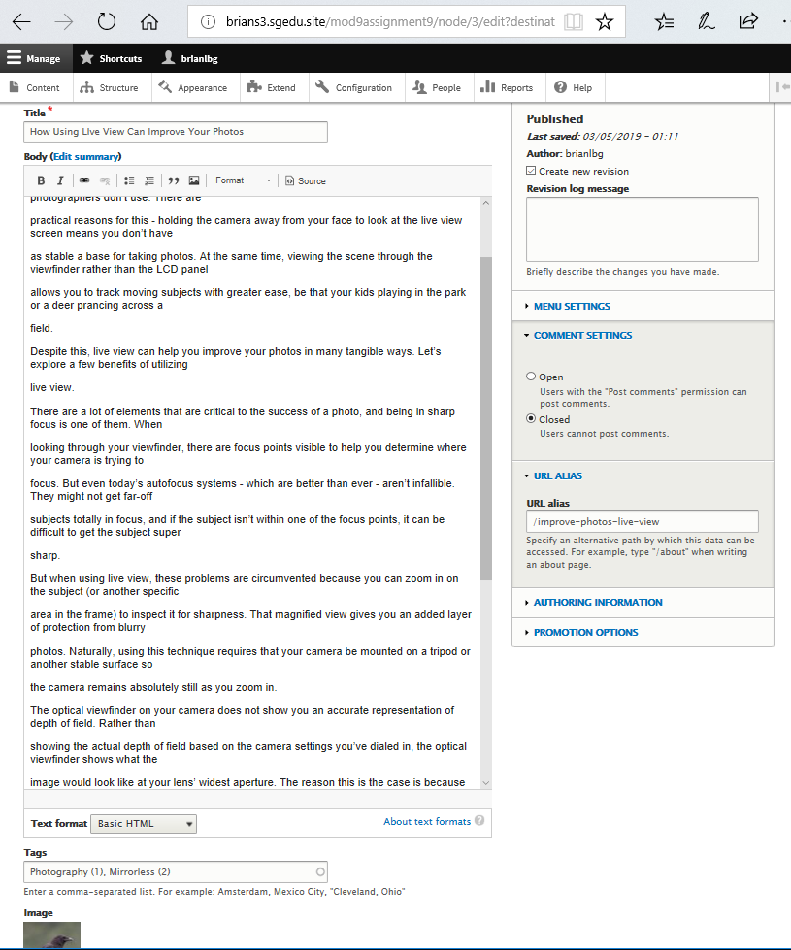 [F02]
3. SCREEN CAPTURE – Backend Article nodes Body and Blocks  
   Edit an Article you created and take a screen capture the body and side blocks   
   Show (1-9) see image below: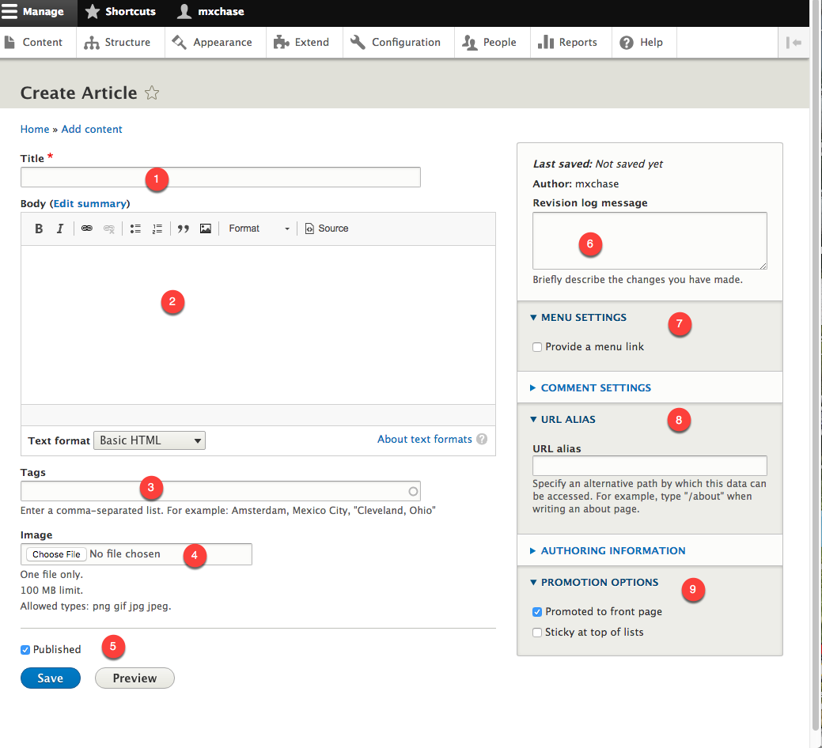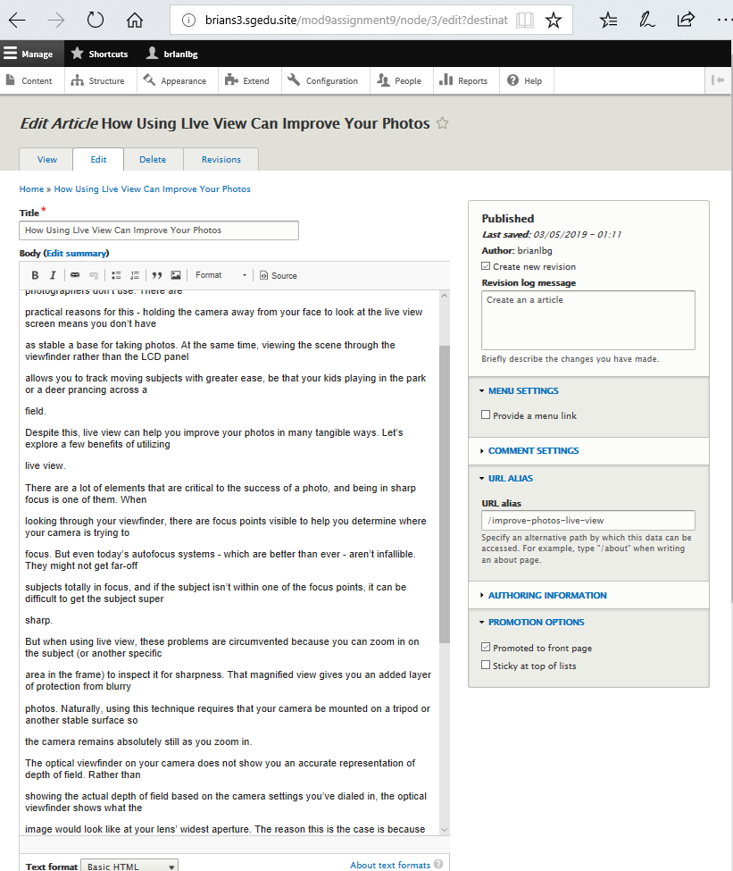

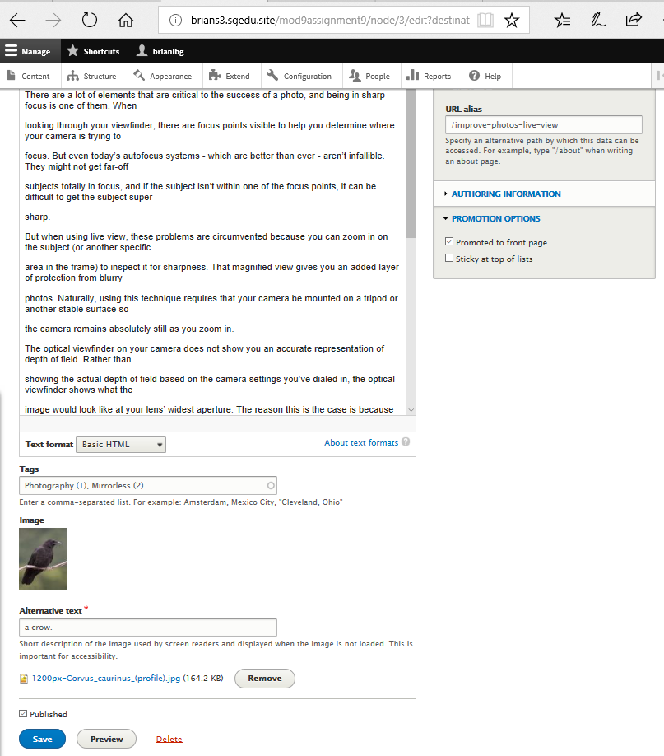 [H03]

1. SCREEN CAPTURE – Front end Article   
   Note: Frontend means a web browser where you are not logged into the Drupal site.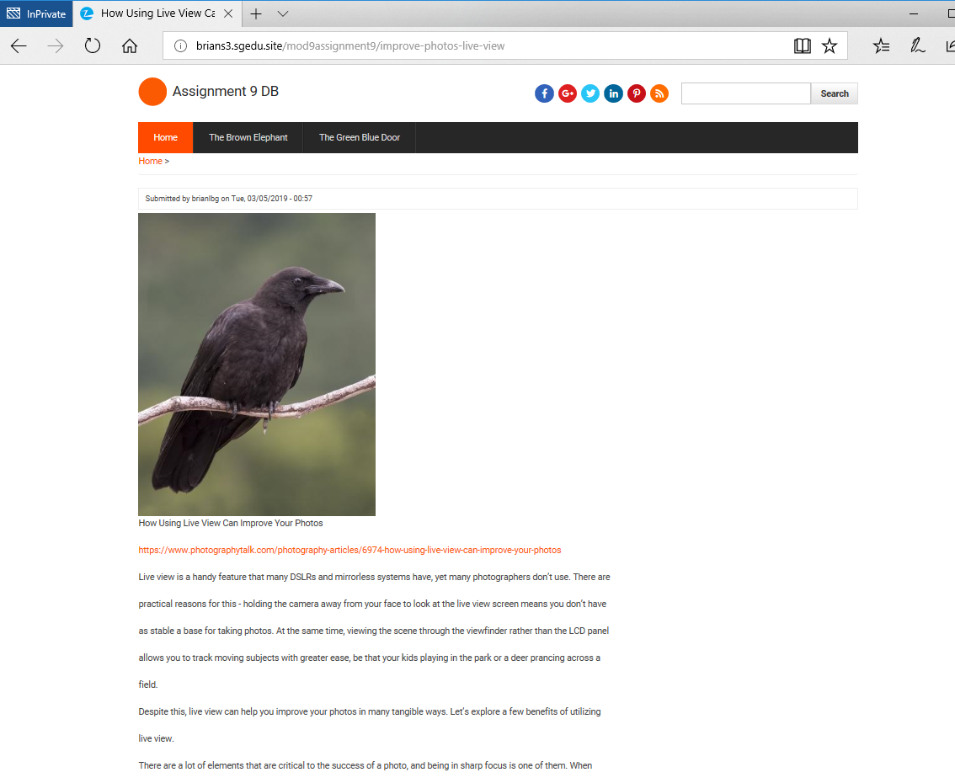

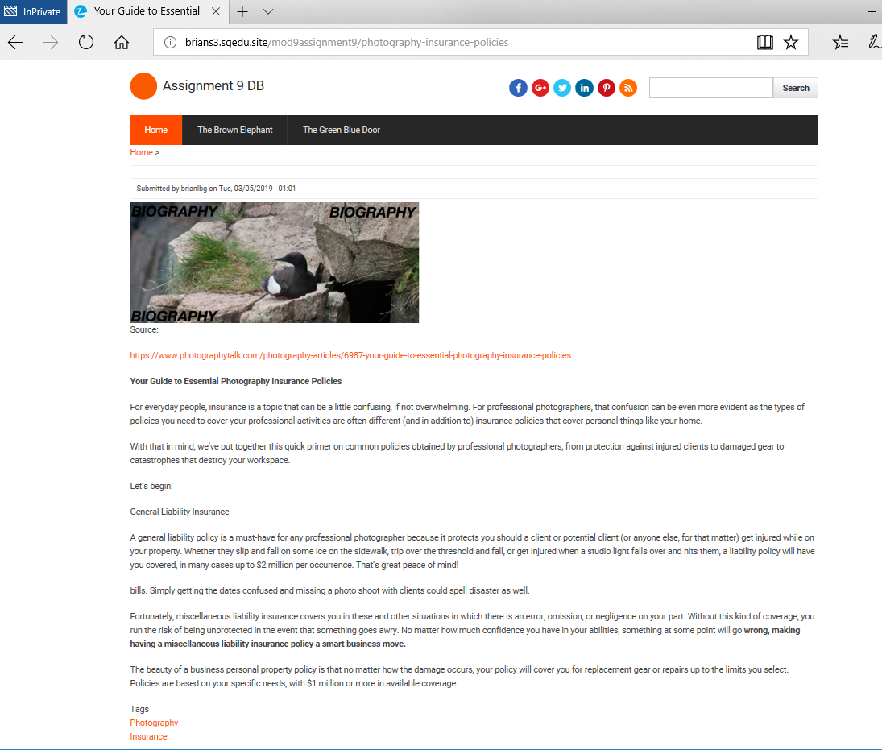 [H04]

1. Go back to the instructions and continue with Part G.

Part G – Contact Us Form:

Contact Us:

1. SCREEN CAPTURE – Backend screen capture of the Extend page, showing the Core Contact module enabled  
   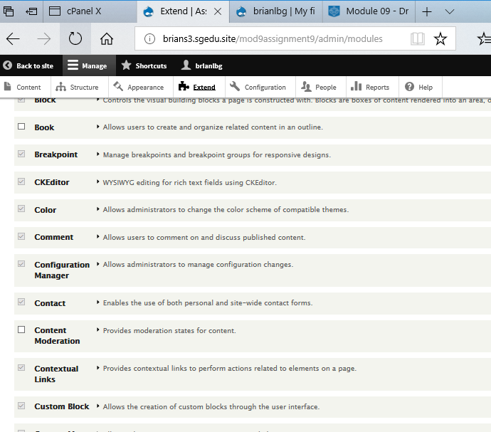 [G01]
2. SCREEN CAPTURE – Backend screen capture of the People > Permissions page, showing the Core Contact site-wide contact form permissions  
   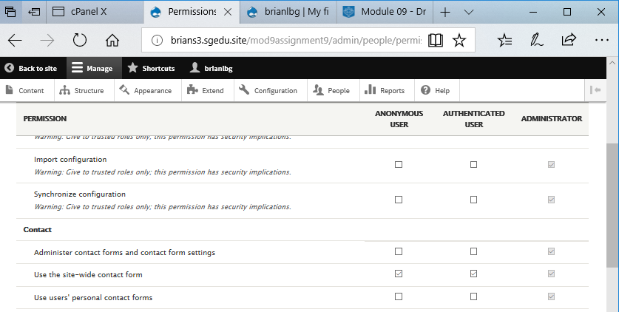 [G02]
3. SCREEN CAPTURE – Frontend of the contact us accessed by an anonymous user   
   Note: Frontend means a web browser where you are not logged into the Drupal site.  
   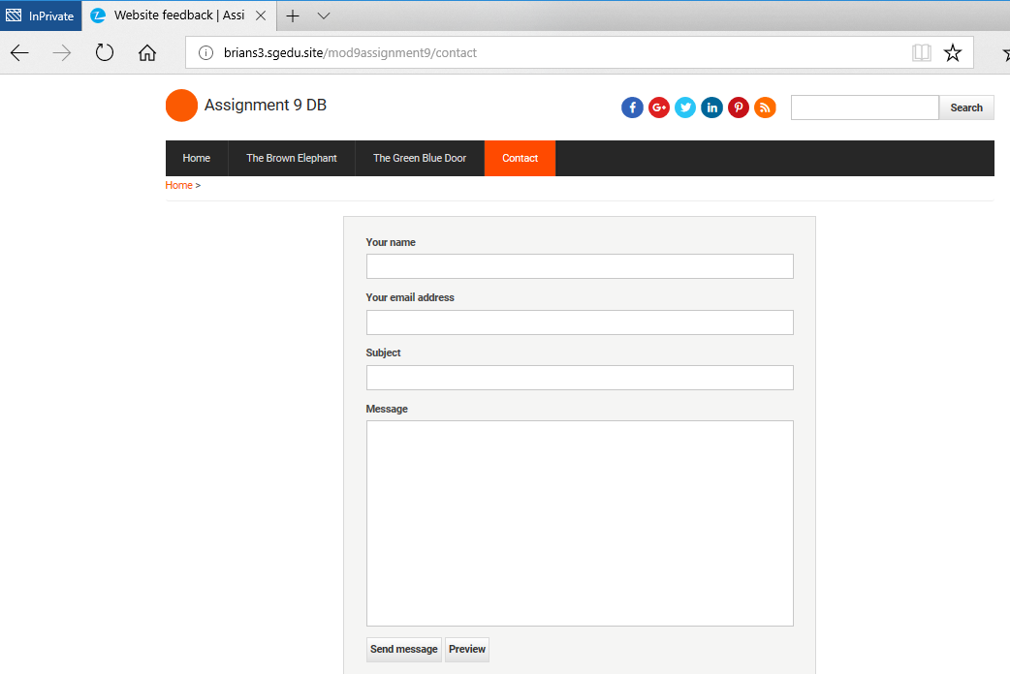 [G03]

Go back to the instructions and continue with Part H.

Part H – Extend Drupal 8 with a Frequently Asked Questions ModuleFrequently Asked Questions:

1. SCREEN CAPTURE – Backend screen capture of the Extend page, showing the FAQ module enabled  
   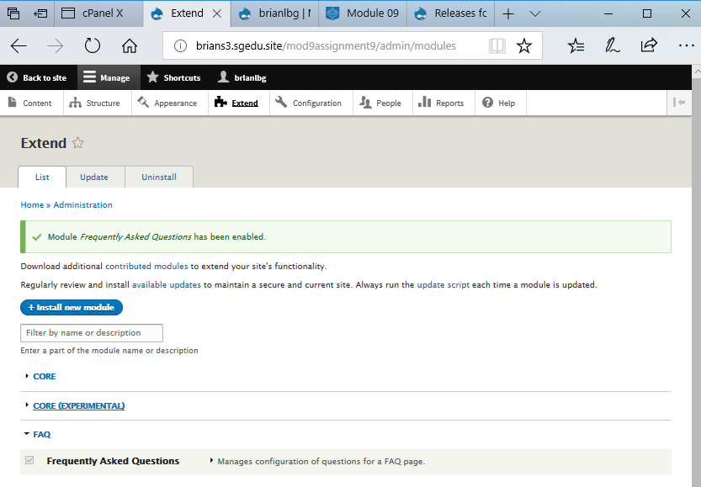 [H01]
2. SCREEN CAPTURE – Backend screen capture of the People > Permissions page, showing the Frequently Asked Questions, View FAQ pages permissions  
   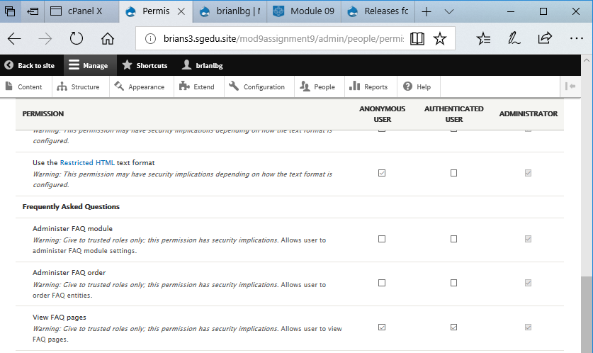 [H02]
3. SCREEN CAPTURE – Frontend of the FAQ accessed by an anonymous user with at least one question expanded in the accordion view  
   Note: Frontend means a web browser where you are not logged into the Drupal site.  
   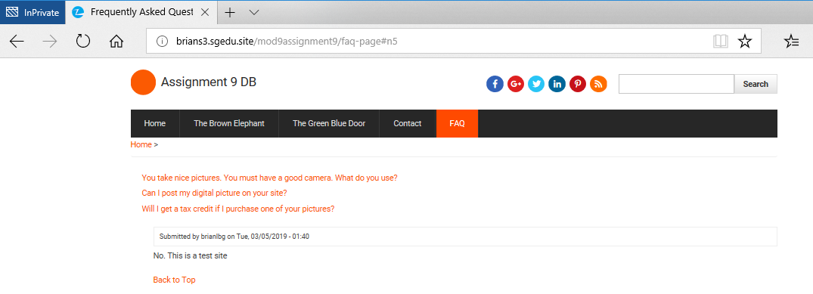 [H03]

Go back to the instructions and continue with Part I.

**Part I- Extend Drupal 8 with a Simple Google Map Module**

Simple Google Maps:

1. What is the name of the Content type that you added the Address field to?  
   Simple GMap [H01]
2. SCREEN CAPTURE – Backend screen capture of the Extend page, showing the Simple Google Map module enabled  
   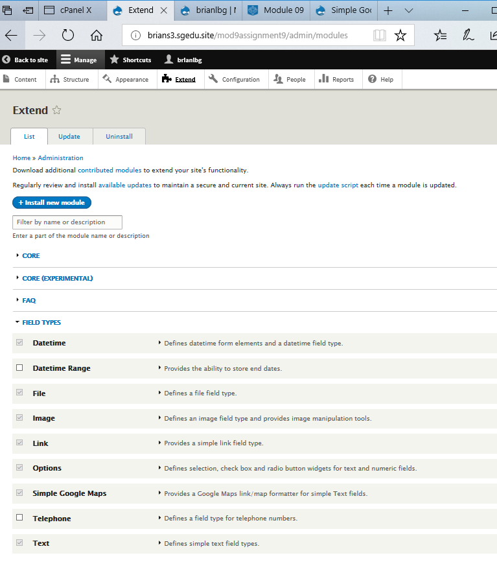 [H02]
3. SCREEN CAPTURE – Backend screen capture of the Structure > Content types > Manage Fields for the Content type you added the Address field to  
   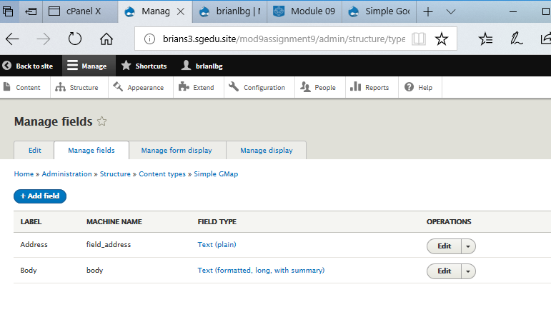 [H03]
4. SCREEN CAPTURE – Backend screen capture of the Structure > Content types > Manage Display for the Content type you added the Address field to  
   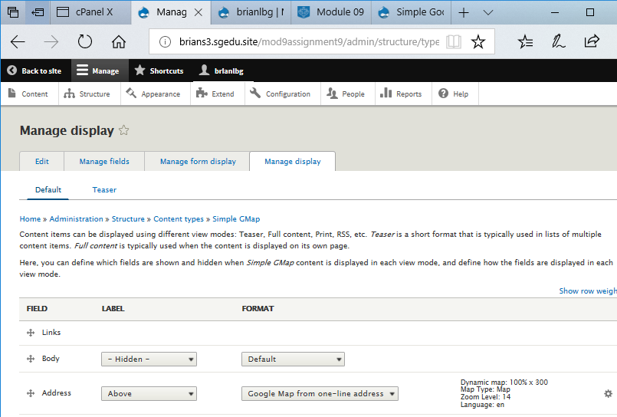 [H04]
5. SCREEN CAPTURE – Frontend of the Google Map page accessed by an anonymous user with the map visible  
   Note: Frontend means a web browser where you are not logged into the Drupal site.  
   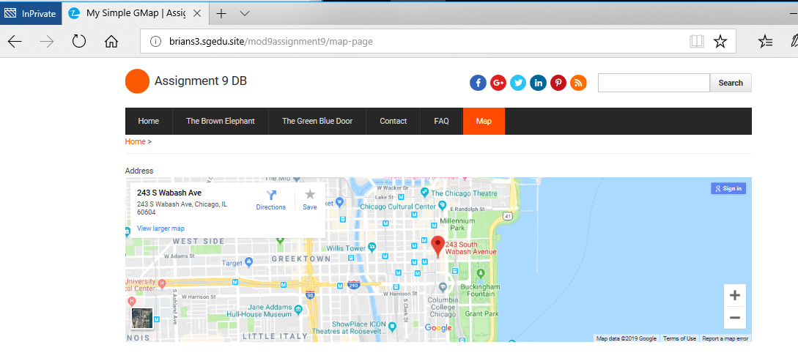 [H05]

Go back to the instructions and continue with Part J.

**Part J – Extend Drupal 8 with a Drupal 8 Core Telephone field**  
Drupal 8 Core Telephone field:

1. What is the name of the Content type that you added the Telephone field to?  
   Simple GMap [J01]
2. SCREEN CAPTURE – Backend screen capture of the Extend page, showing the Telephone field enabled  
   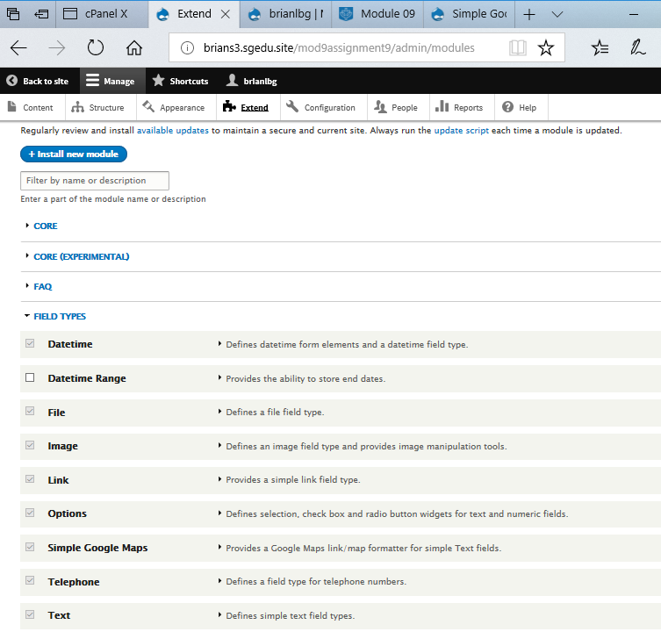 [J02]
3. SCREEN CAPTURE – Backend screen capture of the Structure > Content types > Manage Fields for the Content type you added the Telephone field to  
   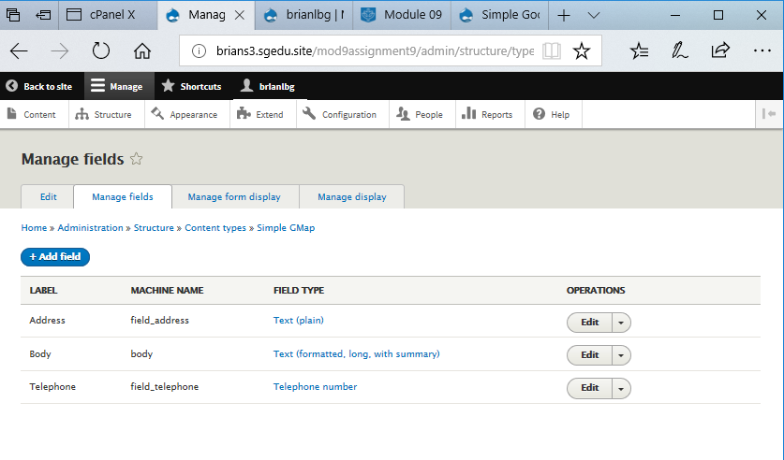 [J03]
4. SCREEN CAPTURE – Frontend of the Telephone page accessed by an anonymous user with the Telephone field value visible  
   Note: Frontend means a web browser where you are not logged into the Drupal site.  
   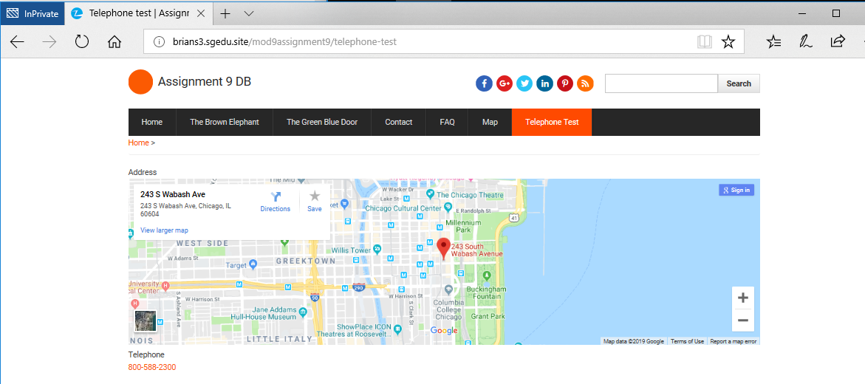 [J04]